​Convert the plain text question into a HumanMessage, which is a symbol wrapper that tells ​LangChain, This text came from the user." ​It carries the user's input and marks it appropriately for the model during the conversation. ​To do this, import HumanMessage from LangChain core messages.
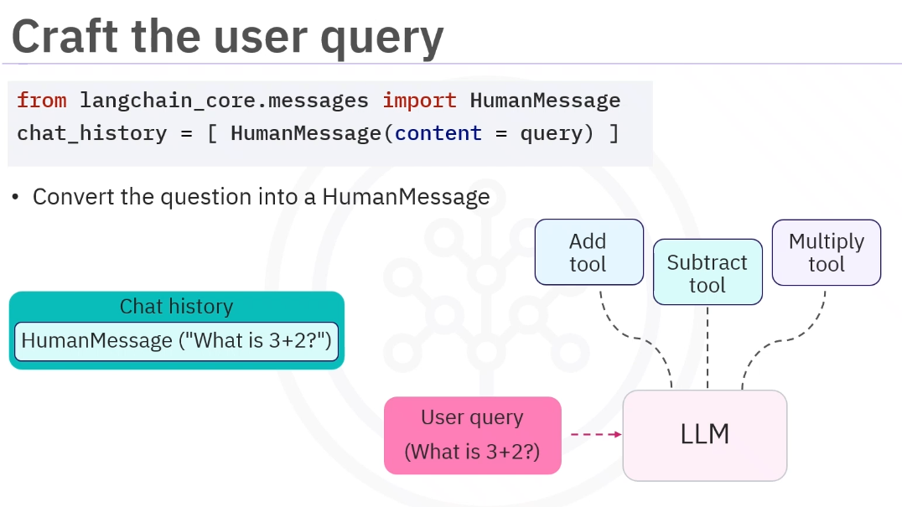
First, pass the complete chat history, which contains the user's question, into LLM with ​tools.
The model's output. ​Instead of a plain text response, an AIMessage is received containing a tool calls array. ​Focus only on the part of the message related to tool usage. ​This is the model's way of saying, "I want to call this function with these arguments."
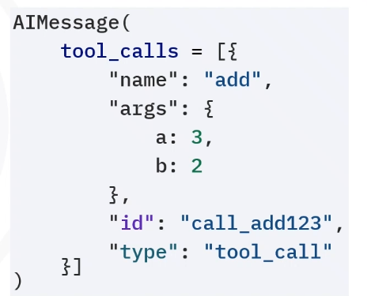
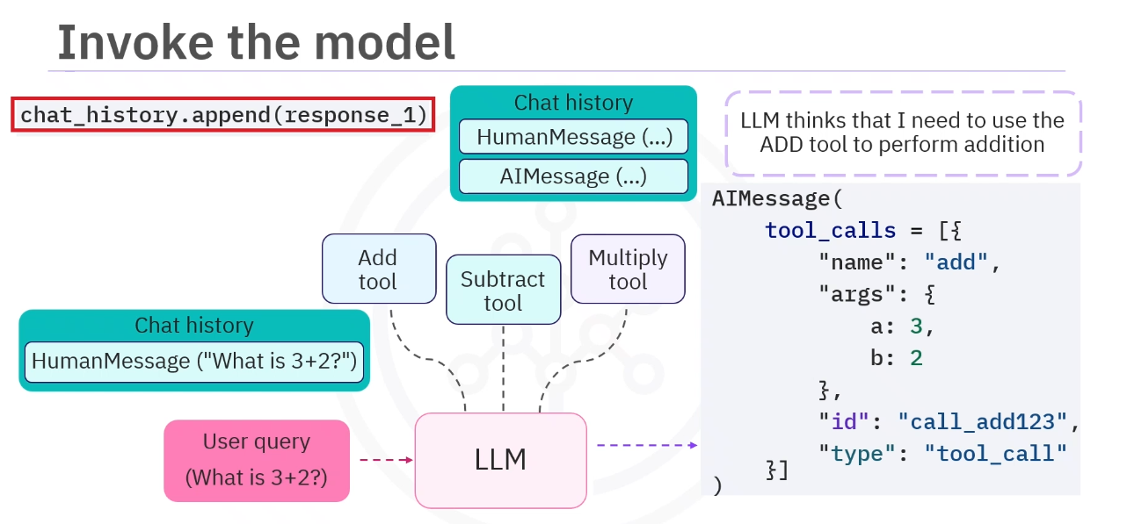
append the AIMessage, including the tool call instruction, into chat_history ​so the next model invocation has access to both the user's original query and the ​model's previous output.
After this when the llm has suggested with the tool call in AIMessage you can parse this tool_calls for the tool name, its args:
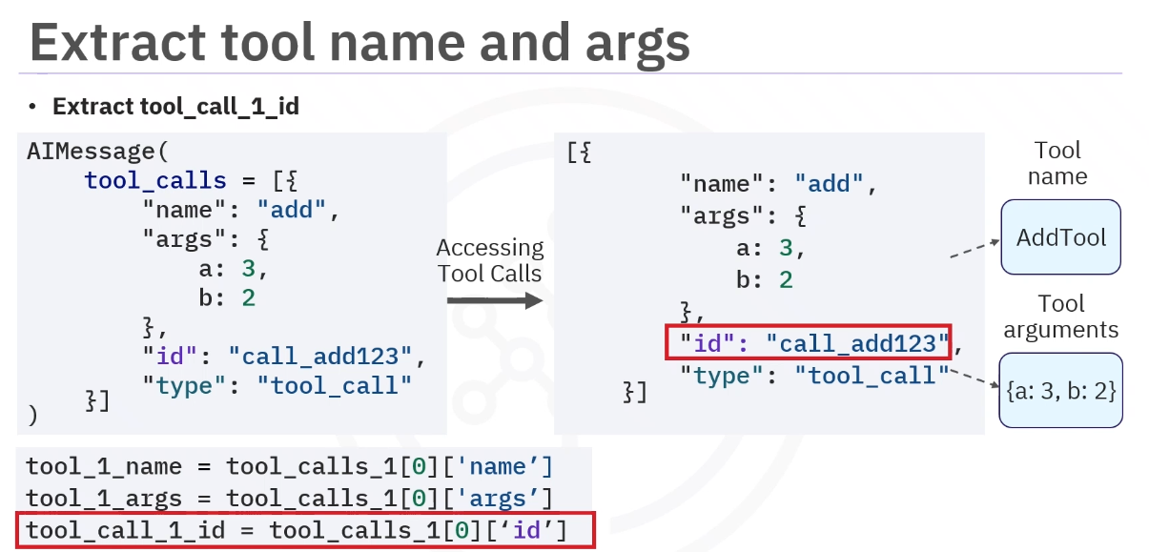
Now we can use the tool map created in previous note to call the function you need. ​The key is the tool name determined by the LLM stored in tool_1_name. ​In addition, use the tool parameters provided by the LLM stored in tool_1_args:
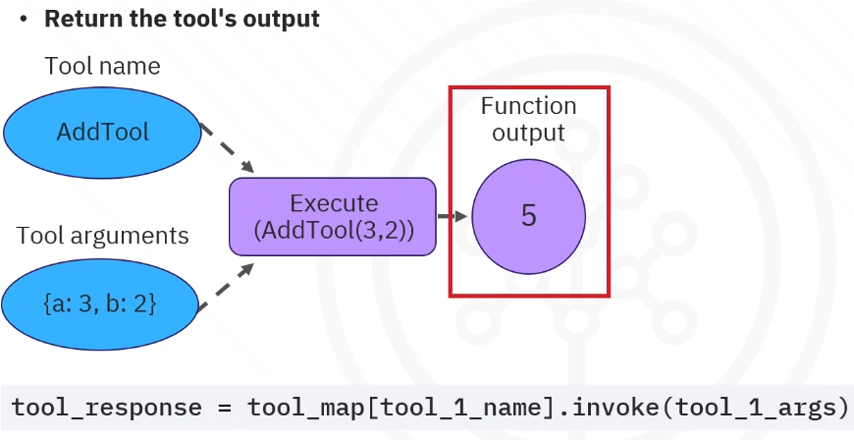 Finally, wrap the tool's output in a Tool Message by creating a Tool Message object. ​Finally, update the chat history by appending the new tool message to the chat history list. ​The history now contains the original HumanMessage, the AIMessage from the model, and ​the new ToolMessage with the tool's result.
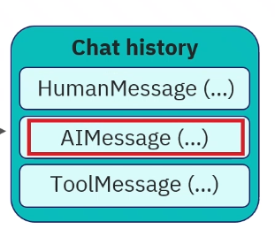
AGENT CLASS:
🧠 What is an “Agent Class”?
👉 In simple terms:
An agent class is a Python class that automates the whole tool-calling process

🔥 Why do we even need it?
From the previous topic, you saw this messy flow:
1. Create chat history
2. Call LLM
3. Extract tool name
4. Extract arguments
5. Call tool
6. Add result to history
7. Call LLM again
👉 Doing this manually every time = ❌ painful

🧠 So we create a class
👉 To wrap everything into one reusable object

🔹 Simple definition
👉
Agent class = code that behaves like an intelligent assistant

🔥 What an agent class does internally
It handles:
✅ 1. Stores chat history
self.chat_history = []

✅ 2. Sends input to LLM
llm.invoke(...)

✅ 3. Detects tool calls
response.tool_calls

✅ 4. Executes tools
tool_map[name].invoke(args)

✅ 5. Sends result back to LLM

✅ 6. Returns final answer

🔹 Simple Example (clean)
class SimpleAgent:
def __init__(self, llm, tools):
self.llm = llm.bind_tools(tools)
self.tools = {tool.name: tool for tool in tools}
self.chat_history = []
def run(self, user_input):
# Step 1: add user input
self.chat_history.append({"role": "user", "content": user_input})
# Step 2: call LLM
response = self.llm.invoke(self.chat_history)
# Step 3: check tool call
if hasattr(response, "tool_calls"):
tool_call = response.tool_calls[0]
tool_name = tool_call["name"]
args = tool_call["args"]
# Step 4: execute tool
result = self.tools[tool_name].invoke(args)
# Step 5: add tool result
self.chat_history.append({
"role": "tool",
"content": str(result)
})
# Step 6: call LLM again
final_response = self.llm.invoke(self.chat_history)
return final_response.content
return response.content

🧠 How you use it
agent = SimpleAgent(llm, [add, subtract])
agent.run("What is 2 + 3?")
👉 Output:
5

🔥 Real meaning (important)
👉 Agent class is:
- A wrapper around LLM + tools
- That makes them behave like a smart system

